Name: Yasmien L. Tosloc Date:04/16/2026
Year & Section: BSIT- 3A Score:

Co-Fit: Gym Operations and Membership System

System Description:
The Gym Operations and Member Management System makes it easier for a fitness center to run its daily business by combining member services, administrative controls, and trainer functions into one platform. It helps users keep track of their memberships, fitness progress, workout schedules, and billing in a way that makes operations run more smoothly and improves the user experience. The system makes sure that everyone involved customers, trainers, and administrators \can access the features that are relevant to their roles.
The system lets you keep an eye on and manage gym operations in real time, such as keeping track of attendance, making reports, and planning workouts. Centralizing these tasks cuts down on manual work, lowers the chance of mistakes, and makes it easier for members and staff to talk to each other.
Actors/Users:
- Customer (Member) – Uses the system to register, view workout plans, track progress, and check membership status.
- Trainer – Manages workout schedules, tracks member progress, monitors attendance, and updates workout logs.
- Admin – Oversees overall system operations including membership management, billing, report generation, and system control.
Main System Functions:
- User authentication (Login) and profile management
- Membership registration and management
- Viewing and scheduling workout/training sessions
- Tracking member progress and attendance
- Payment and billing processing
- Generating reports
- Administrative control and operational oversight

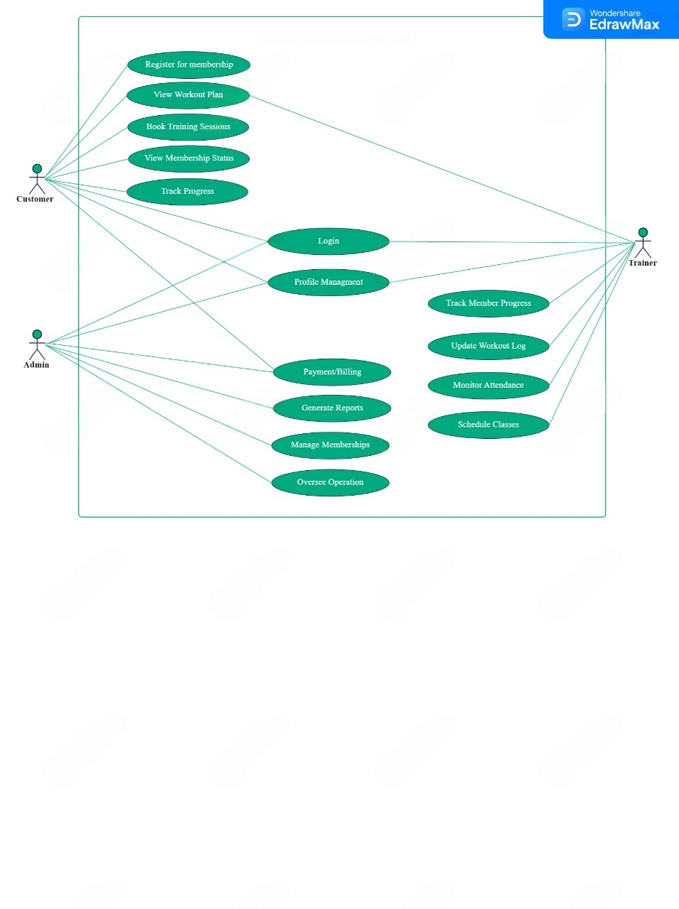
UML Diagram (Use case Diagram)
Co-Fit: Gym Operations and Member Management System

